**Title**

**Name of Student**

**Affiliation**

**Course name**

**Instructor name**

**Due Date**

**Social Media Campaign Development**

**Introduction**

Nike is one of the well-recognized global companies that designs, markets as well as distributes athletic footwear, equipment, accessories, and apparel to women, men, and children. Nike Inc was founded in 1964 and gradually it attained significant attention across the globe because of the delivery of innovative products. The products of Nike are known for their style and quality (About Nike, n.d.). For the purpose of this assignment, the chosen product is Nike Air Max. Nike Air Max was introduced in 1987 which revolutionized the footwear industry. The birth of Nike's Air Max ignited a love for the iconic cushioning system of Nike (Nike, 2024). Nike Air Max offers comfort and style to the customers. Over the years, Nike has invested significant efforts to improve Air Max and eventually, this product has become a cultural icon (Nike, 2024).

This assignment aims to conduct social media campaign development for the products of Nike, Air Max. Social media campaign development for Nike is chosen because social media has a huge potential to increase the brand strength and market presence of the product. Social media helps companies to reach diverse and broader audiences (Kim, 2020). Nike has strong customer base and the company is renowned for its innovative design, social media can help to provide engaging content about Air Max and increase awareness among target audience about the effectiveness of this product. Through social media campaign, brand engagement can be driven which will lead to increasing sales (Kim, 2020). This report sheds limelight on the choice of platforms, target audience, content strategy, and planning for engagement and analytics for Air Max.

**Methodology**

In order to develop a comprehensive social media campaign for Air Max of Nike, a secondary research approach was taken. In terms of secondary research methods, research papers, news websites, grey literature, and websites of Nike were utilized. The research papers offered help in terms of understanding customer behavior, role of different social media platforms, and market trends. Different reputed websites offered up-to-date information about the competitor's activities as well as the performance of Nike. The valuable knowledge helped in shaping the social media campaign for Air Max. The official website of the company, Nike, informs about the product details, commitment, and mission of Nike.

In order to analyze the collected data, a qualitative method was used. The information presented in research papers, news articles, grey literature, and websites was analyzed in terms of strategies and content. Different emerging trends in different social media platforms were also analyzed. The findings from different sources were synthesized to develop an effective and coherent campaign for Nike. Overall, leveraging data from diverse sources helped to come up with effective approach and design a well-informed social media campaign.

**Findings and Analysis**

**Choosing the Platforms**

Choosing the right platforms is crucially important for the success of the social media campaign for Nike Air Max. For this purpose, the chosen social media platforms are Instagram, TikTok, and Twitter. Instagram has a huge potential to increase awareness of the product and improve customer engagement because it is a visual-centric platform that enables businesses and companies to showcase their products through captivating videos and images. The visual nature of Instagram helps in creating an emotional connection with the audience (Rahman et al., 2022). Figure 1 below depicts that Instagram has more potential for user engagement compared to Facebook because the image posted via Instagram attains 23% more engagement compared to Facebook (Sharma, 2024). Nike Air Max sneakers can utilize this platform to demonstrate innovative and appealing designs and attain the attention of the users. Short engaging videos and direct link to purchase the product can be posted on Instagram to convert the interest of the users into purchasing and sales.

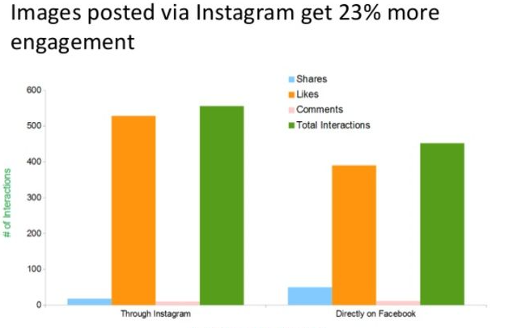

Figure 1: Source: Sharma (2024)

In the past few years, TikTok has taken significant attention from the people. Companies use TikTok to attain social media marketing and increase the buying attention of the potential customers. The algorithm of TikTok favors creative content and fosters a high level of user engagement (Meliawati et al., 2023). Nike can leverage Tik Tok platform and create hashtag challenges, for example, #Just_Do_ It_With_AirMax.

Twitter is another important impactful social media platform that offers real-time communication and enables users to share live updates and get engaged with tending topics. Twitter offers real-time interaction, drives conversation, and increases the visibility of the brands (Kim, 2020). Nike can use Twitter in terms of Twitter polls related to the trend in Air Max and can also leverage hashtag i.e. #DoAirMax, #AirMaxChallenge, etc. Hashtag on Twitter has significant importance as depicted by Flyte (n.d.) in figure 2. Twitter users have been increasing gradually which helps brands and companies to target a wide range of audiences. Figure 3 sheds limelight on the growth of users in the era from 2017 to 2023.

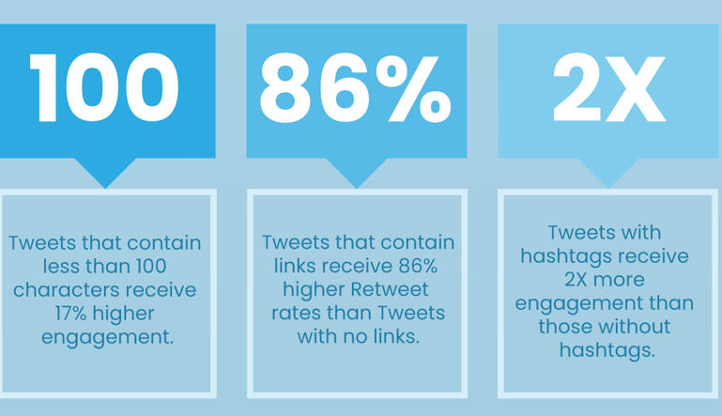

Figure 2: Source: Flyte (n.d.).

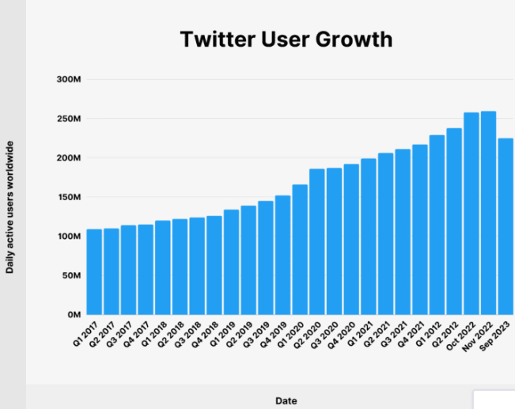

Figure 3: Source: Dean (2024)

Overall, Nike needs to use Instagram, TikTok, and Twitter to promote Air Max and create buzz about the effectiveness of this product. These platforms depict promising aspects in the promotion of this product and convert the interests of the target audience to actual purchase decisions.

**Defining the Target Audience**

The target audience of Nike is age-inclusive and diverse. Nike targets people of all groups and both female and male gender. More specifically, in terms of demographics, the target audience belong to the age group of 18-40 years and the income of the target audience varies. Figure 4 by Jordano (2018) informs that the highest percentage of Nike's audience (41%) belongs to the age group 18 to 24 years. It implies that in the social media campaign, this group must be focused specially. In terms of psychographics, the interests of the target audience include sports, fitness, and fashion. They are active and tech-savvy individuals who value self-expression, authenticity, cultural in touch, and connections (Martucci, 2020). Nike mostly has a loyal customer base and its customers tend to experience a sense of connection with the brand. For Air Max, the target audience is young individuals who belong to the age group 17 to 25 years, who are innovative, bold, independent, as well as look for fresh styles. To the target audience of Air Max, sneakers is a means to express their personality and these individuals seek to stay ahead of the trend (Martucci, 2020).

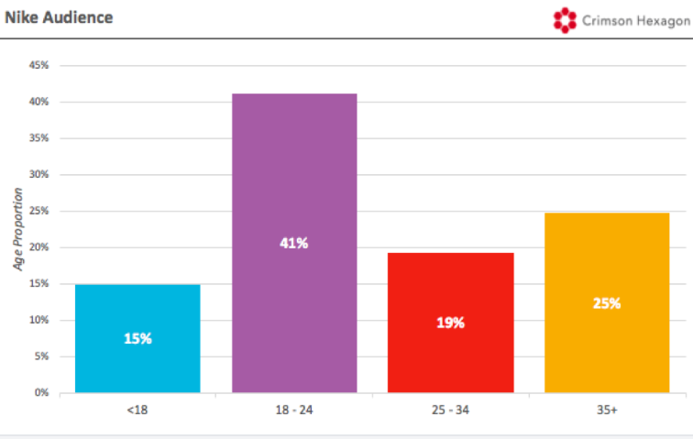

Figure 4: Source: Jordano (2018)

Thus, in order to attract the target audience, Nike can use diverse engagement strategies. For example, Nike can create exclusive content to spark conversation about Air Max. The storytelling approach can be used to highlight the uniqueness and cultural significance of the product. Collaboration with artists as well as designers can be utilized to create visually appealing content (Kim, 2020). Nike needs to pay attention to the aspect of emotional connection with the brand. If the target audience develops an emotional connection with the brand then it can lead to purchase and repurchase which will eventually increase the sales of the company.

**Creating the Content Strategy**

The content strategy for the social media campaign of Air Max needs to ensure that it incorporates the interests and preferences of the target audience of Air Max and the content is relevant across different platforms (Instagram, TikTok, and Twitter). First of all, there must be an effective product showcase. Nike needs to use high-quality images of Air Max and comprehensively highlight the key features, effectiveness, and design of this product. Additionally, Nike also needs to sheds limelight on the way technology has integrated into Air Max to maximize the experience of the customers. For the purpose of product showcase, the social media platform, Instagram will be utilized (Rahman et al., 2022).

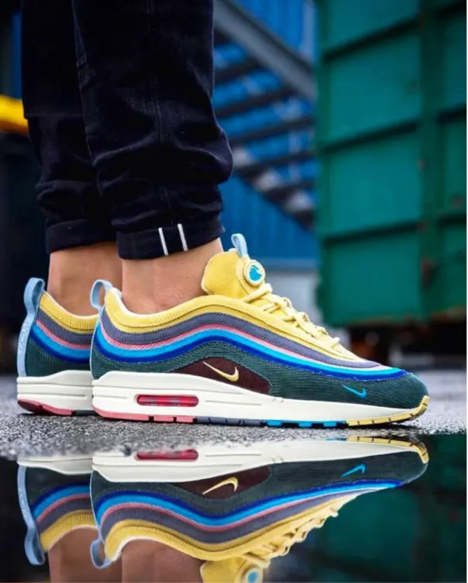

Figure 5: Source: Nike (n.d.)

Another content strategy which Nike can use is the incorporation of user-generated content in social media campaigns. User-generated content refers to the large-scale crowd-sourcing initiative that enables users to express and share their ideas (Agarwal, 2020). User-generated content is self-generated media content that increases the awareness of the product (Agarwal, 2020). Nike can encourage its customers to share their feelings and experiences with Air Max through hashtags, for example, #My_Air_Max_Story. In order to implement this content strategy, the social media platforms that Nike can use include Instagram, TikTok, and Twitter. The use of hashtags to provide the opportunity to customers to share their experiences will help Nike to attract new customers and strengthen its customer base (Kim, 2020).

Another content strategy is that Nike can use is the challenges and giveaways approach to create buzz about Air Max and increase customer engagement with this product. Instagram, TikTok, and Twitter all of these platforms can be used to host creative giveaways and arrange reward loyalty programs for the customers. Similarly, lifestyle content is another effective content strategy that Nike can use to create awareness and boost engagement about Air Max. Nike needs to create content that sheds limelight on the way Air Max brings positivity and class to life. For this purpose, Instagram can be used.

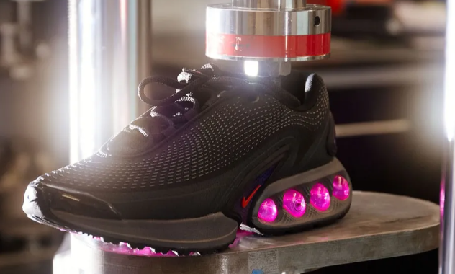

Figure 6: Source: Chow (2024)

Overall, with the help of content strategy (product showcase, user-generated content, giveaway approach, and lifestyle content), Nike will be able to make an impact of Air Max on the target audience.

**Content Calendar**

|  |  |  |  |  |  |  |  |
| --- | --- | --- | --- | --- | --- | --- | --- |
| **Week** | **Monday** | **Tuesday** | **Wednesday** | **Thursday** | **Friday** | **Saturday** | **Sunday** |
| **One** | Product teaser | UGC spotlight | History of Nike | Posts on Instagram | Product teaser | Lifestyle shoot | Weekend contest |
| **Two** | Announcement of the release of Air Max | Creating buzz through hashtags | Stories of people about Nike's products | Interactive Q&A answer session | Hashtag challenges | UGC compilation | Giveaway announcement |
| **Three** | Videos on Air Max style | Design insights | Air Max unboxing | UGC highlights | Twitter poll | Hashtag challenge | Winner announcement |
| **Four** | Videos on Air Max style | User review | Twitter poll | UGC highlights | Instagram interactive Q&A | Air Max event coverage | Winner Event coverage |

**Planning for Engagement and Analytics**

There are numerous engagement strategies that Nike can use in the social media campaign of Air Max. These engagement strategies include interactive posts, hashtags, live sessions as well as responses to comments. In terms of interactive posts, Nike can use questions as well as polls on social media platforms to keep the target audience engaged and assess their preferences and needs (Kim, 2020). Live sessions can be arranged on Instagram to interact with potential customers and existing customers of Air Max. Similarly, hashtags for example, #AirMaxLove, #AirMaxLife, etc would be used to enhance the discoverability of Air Max. Similarly, responsive behavior is required by Nike on all social media platforms to its customers. It is important to develop interaction with the customers and build an emotional and trusting relationship.

Key performance indicators are used to assess the success or failure of the social media campaign. The key performance indicators that Nike would use are reach and impressions, conversion rates, engagement rates, and hashtag performance (Grave, 2019). The number of users who would see the content on different social media platforms will be identified. The conversion rate will be measured in terms of users making purchase decisions, and the engagement rate will be measured by the number of likes, comments, and shares (Grave, 2019).

**Discussion and Recommendations**

The findings of this report in relation to the social media campaign development for Air Max informs that Instagram, TikTok, and Twitter are effective platforms to promote a product and reach diverse audiences. All these three platforms offer unique opportunities for the brands and products to increase their recognition and sales. Similarly, the findings of the report also inform that a diverse content strategy is needed for the social media campaign development for Air Max. The diverse content strategy helps in engaging diverse audience segments. Similarly, interactive posts, hashtags, and giveaways foster a sense of community and increase engagement of the customers (Kim, 2020).

It is recommended that the social media campaign leverage user-generated content to maximize the impact and awareness of the product and services (Agarwal, 2020). Similarly, it is also recommended that content must be optimized for each platform. Social media analytics tools must be used to evaluate the performance of the content strategy and the impact of the campaign. Overall, the implementation of these aspects helps in increasing brand visibility and sales of the company.

**Conclusion**

The products of Nike are known for their style and quality. Nike's Air Max is one of the products that has become a cultural icon. For this purpose, of the social media campaign for Nike Air Max, the chosen social media platforms are Instagram, TikTok, and Twitter. These platforms depict promising aspects in the promotion of this product and increasing sales. The target audience of Nike is age-inclusive and diverse. Nike targets people of all groups and both female and male gender. Nike can use diverse engagement strategies for target audience to develop an emotional connection with the brand. The content strategy that Nike can use includes product showcase, user-generated content, giveaway approach, and lifestyle content. The key performance indicators that Nike would use are reach and impressions, conversion rates, engagement rates, and hashtag performance.

**References**

About Nike. (n.d.). WELCOME TO NIKE, INC. <https://about.nike.com/en/company>

Agarwal, M. (2020). Importance of User Generated Content as a part of Social Media Marketing that drives Customer‟ s Brand Awareness and Purchase Intentions. *The International journal of analytical and experimental modal analysis*, *12*(2), 3071. <https://www.academia.edu/download/62513151/Importance_of_User_Generated_Content_as_a_part_of_Social_Media_Marketing_that20200328-51052-1favrrn.pdf>

Chow. A. (2024). Introducing Nike’s Next Era of Air: Air Max Dn. Lifestyle Asia. <https://www.lifestyleasia.com/hk/style/fashion/air-max-dn-dynamic-innovation-next-era-release-info/>

Dean, B. (2024). X (Twitter) Statistics: How Many People Use X? BlackLinko. <https://backlinko.com/twitter-users>

Flyte. (n.d.). Hashtags Explained: The Complete Guide to Hashtags in Social Media. <https://www.takeflyte.com/blog/hashtags-explained>

Gräve, J. F. (2019). What KPIs are key? Evaluating performance metrics for social media influencers. *Social Media+ Society*, *5*(3), 2056305119865475. <https://doi.org/10.1177/2056305119865475>

Jordano, L. (2018). Social Media Analysis Shows Nike Scored a Major Win With Kaepernick Ad. Entrepreneur. <https://www.entrepreneur.com/growing-a-business/social-media-analysis-shows-nike-scored-a-major-win-with/320516>

Kim, C. M. (2020). *Social media campaigns: Strategies for public relations and marketing*. Routledge. <https://www.academia.edu/download/60766001/Social_Media_Campaigns20191001-8906-1y3fviz.pdf>

Martucci, I. (2020) *#AIRMAXDAY2019: Identity and Engagement With Air Max Day 2019 on Twitter* (Doctoral dissertation, Toronto Metropolitan University). <https://rshare.library.torontomu.ca/articles/thesis/_airmaxday2019_Identity_and_Engagement_With_Air_Max_Day_2019_on_Twitter/14654226/1/files/28136010.pdf>

Meliawati, T., Gerald, S. C., & Aruman, A. E. (2023). The effect of social media marketing Tiktok and product quality towards purchase intention. *Journal of Consumer Sciences*, *8*(1), 77-92. <https://doi.org/10.29244/jcs.8.1.77-92>

Nike (2024). The History of the Air Max 1. <https://www.nike.com/a/air-max-1-history>

Nike. (n.d.). Nike Air Max. <https://www.nike.com/ph/air-max>

Rahman, W. N. A., Mutum, D. S., & Ghazali, E. M. (2022). Consumer engagement with visual content on Instagram: Impact of different features of posts by prominent brands. *International Journal of E-Services and Mobile Applications (IJESMA)*, *14*(1), 1-21. <https://doi.org/10.4018/IJESMA.295960>

Sharma, S. (2024). Instagram Marketing: 6 Reasons Why Instagram Is So Popular. SocialPilot. <https://www.socialpilot.co/blog/instagram-over-other-social-media-platform>